Draw a UML class diagram showing the relationships between each pair of classes. For associations, show multiplicity and name of association. Don't write attributes or methods.
1. GameSolver plays a Game.
public class GameSolver {  /* no attributes */  public int play(Game game) {  // code omitted  }  } | public class Game {  private int secret;  private int upperBound;  public Game(int upperBound) {...}  public boolean guess(int number) {...}  }

2. Bank Account is owned by a Customer (a kind of Person), and has a sequence of Transactions.
public class BankAccount {  private Customer owner;  protected Long accountId;  private List<Transaction> trans;  } | public class Customer extends Person {  private BankBranch homeBranch;  private Long customerId;  { /* code omitted */ }  }
public class CheckingAccount  extends BankAccount {  private double overdraftLimit;  ...  } | public class Transaction  implements Comparable<Transaction> {  private LocalDate txDate;  private TransactionType txType;  private Image documentImage;  }

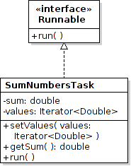

3. Write Java code for this UML. Write as much as you can deduce or guess.

6. Here's is part of a shopping application. A Sale consists of LineItems the customer is buying. Each LineItem has a quantity and a Product. For example, 3 packages of Mama Ramen is a LineItem, "Mama Ramen" is the Product. Each Product has a price (the unit price).
The getTotal( ) method of Sale should compute the total price of all LineItems in the Sale. Can you figure out how to write the code using this UML diagram?

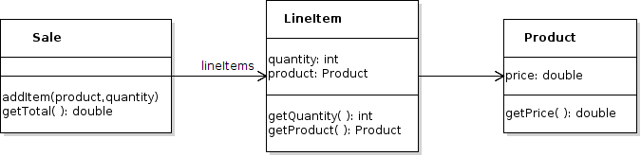

public class Sale {
/** the LineItems in this sale. */
private Collection<LineItem> lineItems;
/**
* Compute the total price of all lineItems in this sale.
*/
public double getTotal( ) {

7. Draw a Sequence Diagram for the add( ) method. Also show what is returned.
class Money {
double value;
String currency;
public Money(double value, String currency) …
public double getValue() { return value; }

}

class Main {

public Money add(Money x, Money y) {

double value = x.getValue() + y.getValue();

String curr = x.getCurrency();

return new Money(value, curr);

}
}
: Main
add(m1, m2)
m1: Money
m2: Money

